UAT Plan

for

Tilt Rush

Index

1. Scope 3

1.1. Objectives and business requirements 3

1.2. Scope 3

2. Testing team 4

3. Environmental requirements 5

3.1. Hardware requirements 5

3.2. Software requirements 5

4. Test Scripts 1

# Scope

## Objectives and business requirements

In this section, outline the business requirements. In other words:

* What are our goals? What are we hoping to accomplish with this project/feature?
* How will we measure success?

I am hoping to have a functioning homescreen, which loads correctly with button features.

## Scope

In this section, outline the scope. This means:

* What is the pain point we’re trying to fix?
* What are we testing exactly, and what are we *not* testing?

Trying to make a working homescreen

* Checking that the homescreen will load accurately
* Checking that the buttons will be pressable
* Not checking that the buttons do anything

## System Diagrams

In this section, paste any drawings or diagrams that help the UAT team understand the program being tested. With each drawing include a brief explanation of how the drawing represents the application or system being tested.

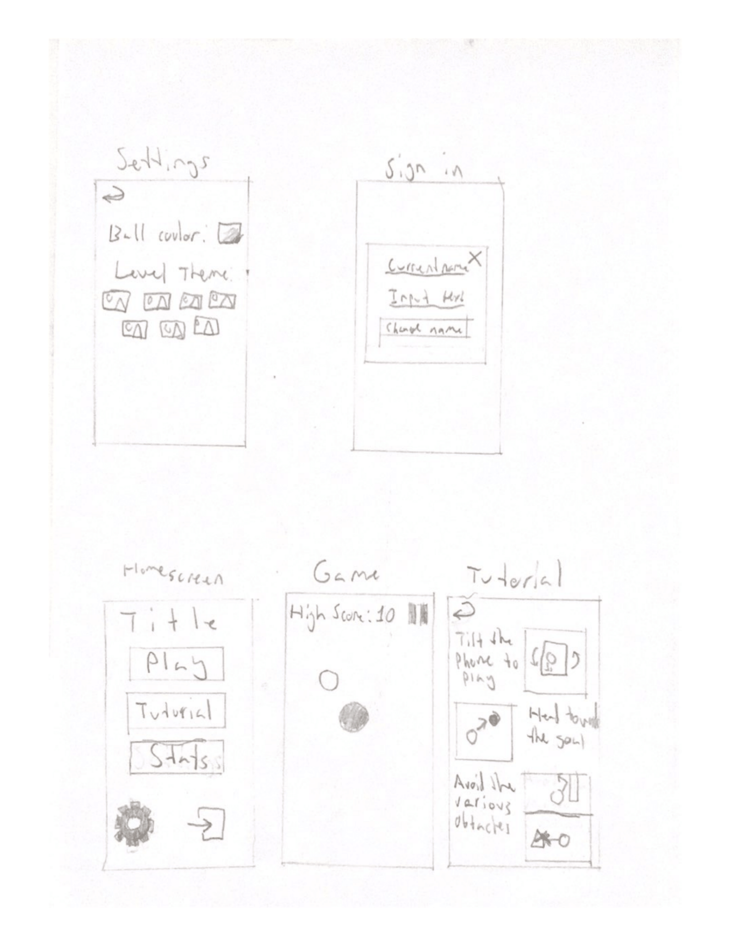

# Testing team

In this section, list out members of your QA team and what their roles will be during UAT.

Example:

| **Name** | **Responsibilities** |
| --- | --- |
| Jack Hunter | Check homescreen |

# Environmental requirements

## Hardware requirements

What hardware has the solution been designed for and should be tested on.

If that is the case, outline the minimal and recommended requirements so the QA team can verify that the software runs on the testers’ machines.

Phone:

Computer:

## Software requirements

If any extra software or dependencies must be downloaded and installed, list them here.

* Google Chrome (or similar browser)

## Network requirements

Some software (design, video editing…) can be demanding on hardware specifications.

If that is the case, outline the minimal and recommended requirements so the QA team can verify that the software runs on the testers’ machines.

* Working internet connection

# Test Scripts

This section is more important than it seems—it is crucial that both the QA team and the testers know what features must be tested, especially if you’re testing a lot at once.

| **Test** | **Describe the feature being tested** | **Describe the user input or test data** | **Describe the pass criteria** |  |
| --- | --- | --- | --- | --- |
| 1.1 | Homescreen | Open app  Press all 5 buttons | Homescreen loads with required visuals (5 buttons, title)  Buttons all press (they don’t do anything) | Tester name: Jack Hunter   |  | PASS | | --- | --- | |  | FAIL |   Observations: |

Write step-by-step, detailed but concise instructions on how to test the feature.